HACKATHON DAY 6

ERROR HANDELING , TESTING & BACKEND INTEGRATION REFINEMENT

# DEPLOYMENT

• CONFIGURE ENVIRONMENT VARIABLES IN YOUR • Prepare code , dependencies , and configurations

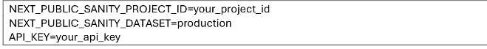•

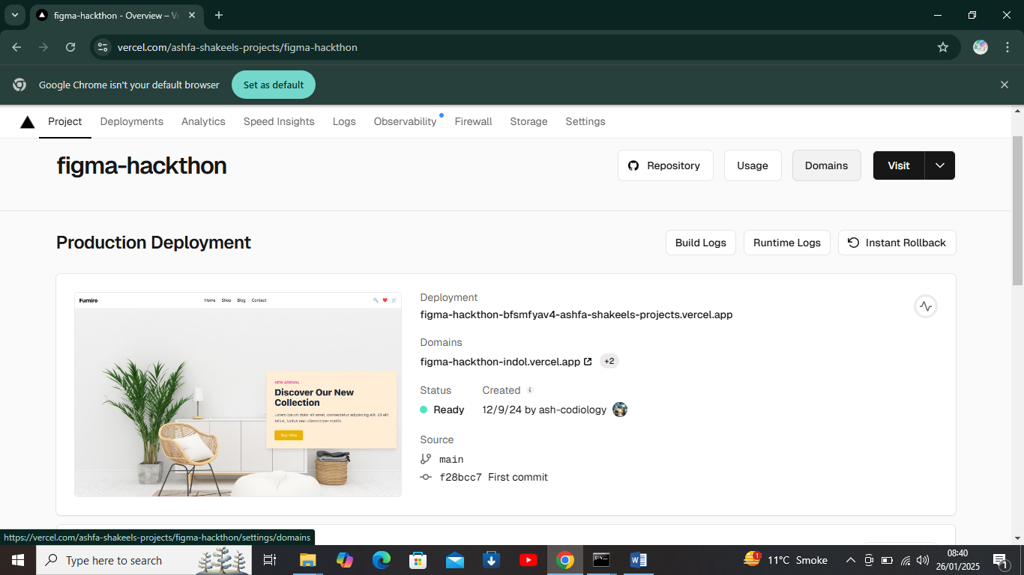

# ERROR HANDELING

* Use console.log or console.error for tracking errors
* Surround critical code with try-catch blocks

# RESOLVING ERRORS

* Debug with detailed error logs and stack traces
* Test fixes locally before deploying

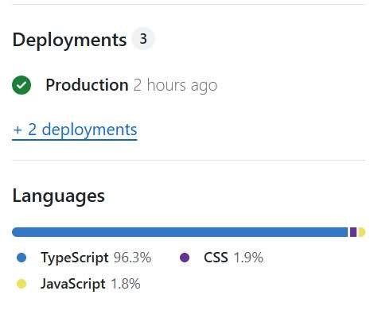

# Checking response of Api

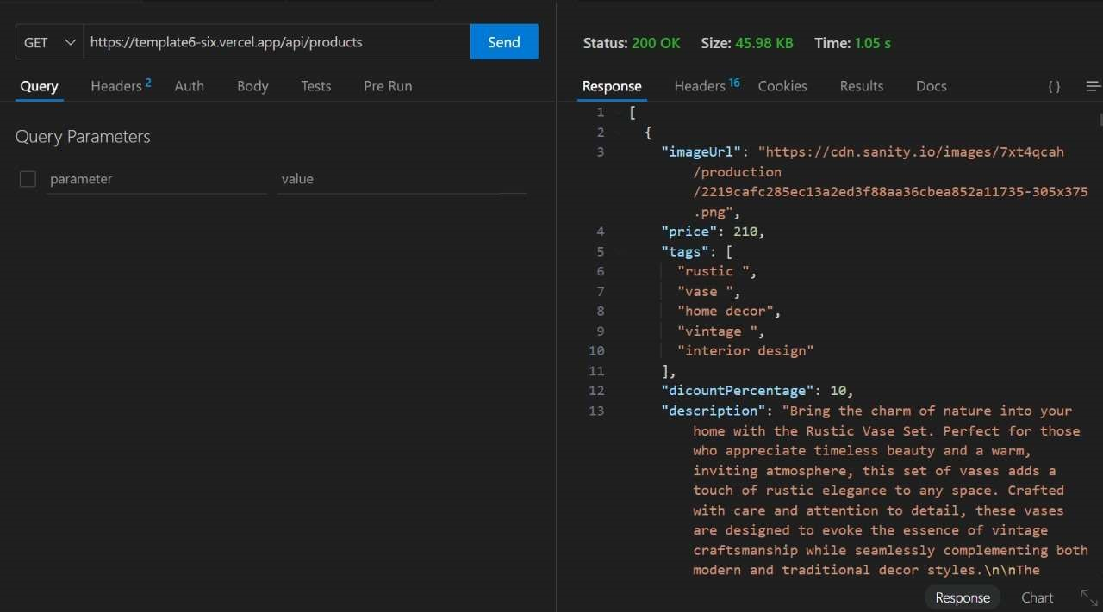

# Test Report Of Market Place

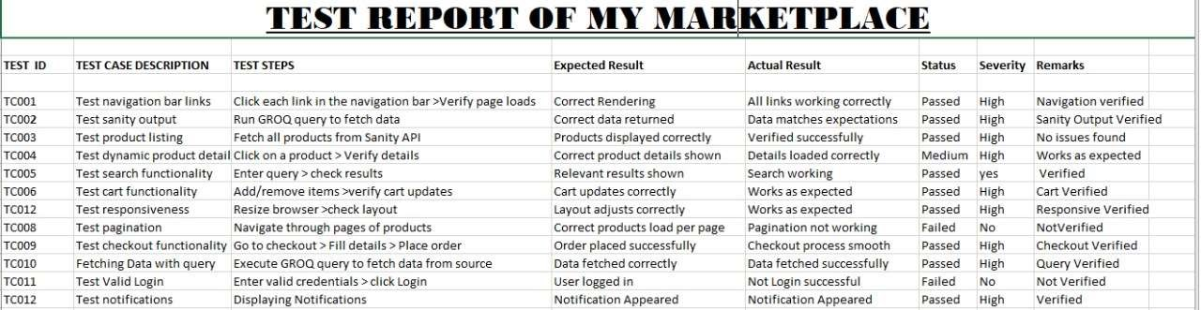

# Performance

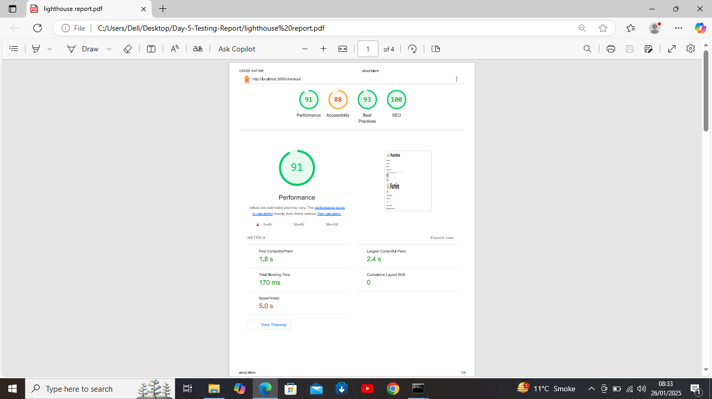

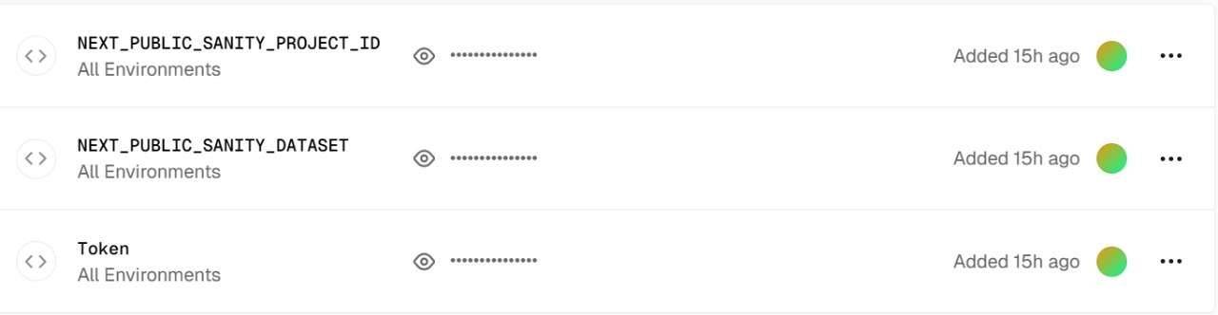Configure Environment Variable in Vercel

• Go to your project > Settings > Environment Variables

# Functional Testing



Final Thoughts

1. **Prioritize What Matters**:
   * Focus on must-have features and polish over nice-to-have extras. Time is of the essence!
2. **Test Like a User**:
   * Run through your app like an end user would.
   * Check for errors, broken links, slow load times, and unexpected behavior.
3. **Backup & Document**:
   * Create a backup of your project (e.g., push to GitHub).
   * Write clear instructions for setting up or running your project for anyone reviewing it (judges, teammates, etc.).
4. **Polish the Presentation**:
   * If you’re showcasing your work, prepare a short demo or walkthrough. Highlight what makes your project unique and impactful.
5. **Deploy & Breathe**:
   * Ensure the live app works as expected.
   * Take a moment to appreciate how far you’ve come during this hackathon. 🎉